UML Diagrams:

**UML DIAGRAMS**

The Unified Modeling Language (UML) is used to specify, visualize, modify, construct and document the artifacts of an object-oriented software intensive system under development. UML offers a standard way to visualize a system's architectural blueprints, including elements such as:

* actors
* business processes
* (logical) components
* activities
* programming language statements
* database schemas, and
* Reusable software components.

UML combines best techniques from data modeling (entity relationship diagrams), business modeling (work flows), object modeling, and component modeling. It can be used with all processes, throughout the software development life cycle, and across different implementation technologies. UML has synthesized the notations of the Booch method, the Object-modeling technique (OMT) and Object-oriented software engineering (OOSE) by fusing them into a single, common and widely usable modeling language. UML aims to be a standard modeling language which can model concurrent and distributed systems.

**Sequence Diagram:**

Sequence Diagrams Represent the objects participating the interaction horizontally and time vertically. A Use Case is a kind of behavioral classifier that represents a declaration of an offered behavior. Each use case specifies some behavior, possibly including variants that the subject can perform in collaboration with one or more actors. Use cases define the offered behavior of the subject without reference to its internal structure. These behaviors, involving interactions between the actor and the subject, may result in changes to the state of the subject and communications with its environment. A use case can include possible variations of its basic behavior, including exceptional behavior and error handling.

* **Activity Diagrams-:**
* Activity diagrams are graphical representations of Workflows of stepwise activities and actions with support for choice, iteration and concurrency.In the Unified Modeling Language, activity diagrams can be used to describe the business and operational step-by-step workflows of components in a system. An activity diagram shows the overall flow of control.

**Usecase diagram:**

* UML is a standard language for specifying, visualizing, constructing, and documenting the artifacts of software systems.
* UML was created by Object Management Group (OMG) and UML 1.0 specification draft was proposed to the OMG in January 1997.
* OMG is continuously putting effort to make a truly industry standard.
* UML stands for **U**nified **M**odeling **L**anguage.
* UML is a pictorial language used to make software blue prints

**Collaboration**

A collaboration diagram resembles a flowchart that portrays the roles, functionality and behavior of individual objects as well as the overall operation of the system in real time. Objects are shown as rectangles with naming labels inside. These labels are preceded by colons and may be underlined. The relationships between the objects are shown as lines connecting the rectangles. The messages between objects are shown as arrows connecting the relevant rectangles along with labels that define the message sequencing  
**Class diagram**

The class diagram is the main building block of object-oriented modeling. It is used for general conceptual modeling of the systematic of the application, and for detailed modeling translating the models into programming code. Class diagrams can also be used for data modeling.[1] The classes in a class diagram represent both the main elements, interactions in the application, and the classes to be programmed.

In the diagram, classes are represented with boxes that contain three compartments:

The top compartment contains the name of the class. It is printed in bold and centered, and the first letter is capitalized.

The middle compartment contains the attributes of the class. They are left-aligned and the first letter is lowercase.

The bottom compartment contains the operations the class can execute. They are also left-aligned and the first letter is lowercase.

**Component diagram**

Component diagram is a special kind of diagram in UML. The purpose is also different from all other diagrams discussed so far. It does not describe the functionality of the system but it describes the components used to make those functionalities.

Thus from that point of view, component diagrams are used to visualize the physical components in a system. These components are libraries, packages, files, etc.

Component diagrams can also be described as a static implementation view of a system. Static implementation represents the organization of the components at a particular moment.

A single component diagram cannot represent the entire system but a collection of diagrams is used to represent the whole.

The purpose of the component diagram can be summarized as −

* Visualize the components of a system.
* Construct executables by using forward and reverse engineering.
* Describe the organization and relationships of the components.

**ER Diagram**

An entity relationship diagram (ERD) shows the relationships of entity sets stored in a database. An entity in this context is an object, a component of data. An entity set is a collection of similar entities. These entities can have attributes that define its properties.

By defining the entities, their attributes, and showing the relationships between them, an ER diagram illustrates the logical structure of databases.

ER diagrams are used to sketch out the design of a database.

**Data flow diagram**

Also known as DFD, Data flow diagrams are used to graphically represent the flow of data in a business information system. DFD describes the processes that are involved in a system to transfer data from the input to the file storage and reports generation.

Data flow diagrams can be divided into logical and physical. The logical data flow diagram describes flow of data through a system to perform certain functionality of a business. The physical data flow diagram describes the implementation of the logical data flow

Use case Diagram:

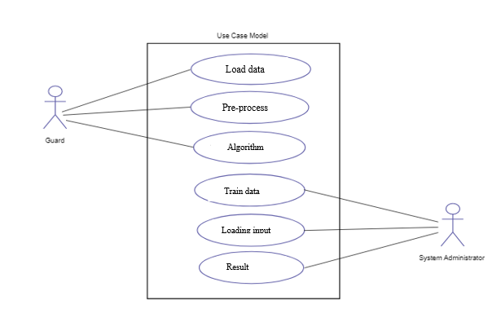

Class Diagram:

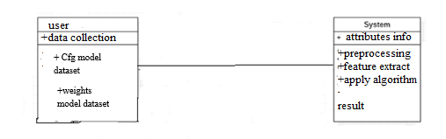

+neural network

Sequence:

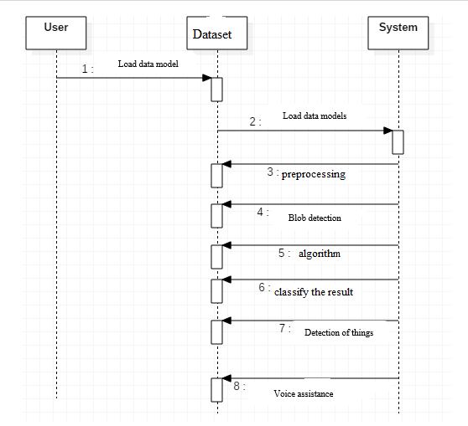

Finally it will identified leaf is affected or not

CNN algorithm

Feature extraction

Load dataset

Input image

Activity:

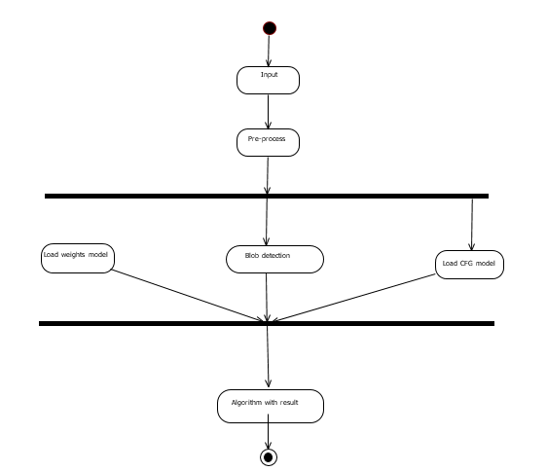

Finally we will identified with disease or not

Feature extraction

Load h5 model

Load tensor flow model

**TESTING**

Software testing is an investigation conducted to provide stakeholders with information about the quality of the product or service under test. Software Testing also provides an objective, independent view of the software to allow the business to appreciate and understand the risks at implementation of the software. Test techniques include, but are not limited to, the process of executing a program or application with the intent of finding software bugs.

Software Testing can also be stated as the process of validating and verifying that a software program/application/product:

* Meets the business and technical requirements that guided its design and Development.
* Works as expected and can be implemented with the same characteristics.

**6.2 Design of test cases and scenarios**

**TESTING METHODS**

* **Functional Testing**

Functional tests provide systematic demonstrations that functions tested are available as specified by the business and technical requirements, system documentation, and user manuals.

Functional testing is centered on the following items:

* Functions: Identified functions must be exercised.
* Output: Identified classes of software outputs must be exercised.
* Systems/Procedures: system should work properly

**Integration Testing**

Software integration testing is the incremental integration testing of two or more integrated software components on a single platform to produce failures caused by interface defects.

**6.3 Validation**

|  |  |  |  |  |  |  |  |
| --- | --- | --- | --- | --- | --- | --- | --- |
| SL# | TEST CASE NAME | DESCRIPTION | STEP NO | STEPS | ACTION TO BE TAKEN(DEESIGN STEPS) | EXPECTED(DESIGN STEP) | TEST EXECUTIONRESULT(PAS/FAIL) |
| 1. | Load models | Objective: use leaf image. | 1 | Step2: | Load data base models | Successfully loaded data base models | Pass |
|  |  |  | 2 | Step2: | Start load image | Successfully loaded with images | Pass |
|  |  |  | 3 | Step3: | Pre-process and feature extraction | Successfully completed pre-process and feature extraction. | Pass |
|  |  |  | 4 | Step4: | Finally it’s detecting with leaf disease | Successfully getting output with accuracy | pass |